**managerial economics and financial analysis**

**UNIT-I**

**Introduction to Managerial Economics:** Imagine for a while that you have finished your studies and have joined as an engineer in a manufacturing organization. What do you do there? You plan to produce maximum quantity of goods of a given quality at a reasonable cost. On the other hand, if you are a sale manager, you have to sell a maximum amount of goods with minimum advertisement costs. In other words, you want to minimize your costs and maximize your returns and by doing so, you are practicing the principles of managerial economics.

Managers, in their day-to-day activities, are always confronted with several issues such as how much quantity is to be supplied; at what price; should the product be made internally; or whether it should be bought from outside; how much quantity is to be produced to make a given amount of profit and so on. Managerial economics provides us a basic insight into seeking solutions for managerial problems.

Managerial economics, as the name itself implies, is an offshoot of two distinct disciplines: Economics and Management.

**Introduction to Economics:** Economics is a study of human activity both at individual and national level. The economists of early age treated economics merely as the science of wealth. The reason for this is clear. Every one of us in involved in efforts aimed at earning money and spending this money to satisfy our wants such as food, Clothing, shelter, and others. Such activities of earning and spending money are called

“Economic activities”. It was only during the eighteenth century that Adam Smith, the Father of Economics, defined economics as the study of nature and uses of national wealth’.

**Dr. Alfred Marshall**, one of the greatest economists of the nineteenth century, writes “Economics is a study of man’s actions in the ordinary business of life: it enquires how he gets his income and how he uses it”.

Lord Keynes defined economics as ‘the study of the administration of scarce means and the determinants of employments and income”.

**Microeconomics**

The study of an individual consumer or a firm is called microeconomics (also called the *Theory of Firm*). Microeconomics deals with behavior and problems of single individual and of micro organization. Managerial economics has its roots in microeconomics and it deals with the micro or individual enterprises. It is concerned with the application of the concepts such as price theory, Law of Demand and theories of market structure and so on.

**Macroeconomics**

The study of ‘aggregate’ or total level of economics activity in a country is called *macroeconomics*. It studies the flow of economics resources or factors of production (such as land, labour, capital, organization and technology) from the resource owner to the business firms and then from the business firms to the households. It deals with total aggregates, for instance, total national income total employment, output and total investment. It deals with the price level in general, instead of studying the prices of individual commodities. It is concerned with the level of employment in the economy. It discusses aggregate consumption, aggregate investment, price level, and payment, theories of employment, and so on.

Though macroeconomics provides the necessary framework in term of government policies etc., for the firm to act upon dealing with analysis of business conditions, it has less direct relevance in the study of theory of firm.

**Management**

Management is the science and art of getting things done through people in formally organized groups. It is necessary that every organization be well managed to enable it to achieve its desired goals. Management includes a number of functions: *Planning, organizing, staffing, directing, and controlling*. The manager while directing the efforts of his staff *communicates* to them the goals, objectives, policies, and procedures; *coordinates* their efforts; *motivates* them to sustain their enthusiasm; and *leads* them to achieve the corporate goals.

**Managerial Economics**

***Meaning & Definition****:*

In the words of **E. F. Brigham and J. L. Pappas** Managerial Economics is “the applications of economics theory and methodology to business administration practice”.

According to **McNair and Meriam**, Managerial Economics is concerned with the use of economc modes of thought to analyze business situation.

M. H. **Spencer and Louis Siegelman** explain the “Managerial Economics is the integration of economic theory with business practice for the purpose of facilitating decision making and forward planning by management”.

It is clear, therefore, that managerial economics deals with economic aspects of managerial decisions of with those managerial decisions, which have an economics contest.

Managerial Economics refers to the firm’s decision making process. It could be also interpreted as “Economics of Management” or “Economics of Management”. Managerial Economics is also called as “Industrial Economics” or “Business Economics”.

**Economics, Business Management and Managerial Economics**

Economics-Theory and Methodology

Business Management-Decision Problems

Managerial Economic-Application of Economics to solving business problems.

Optimal Solutions to Business Solutions

Managerial Economics, therefore, focuses on those tools and techniques, which are useful in decision-making.

**Nature of Managerial Economics**

Managerial economics is, perhaps, the youngest of all the social sciences. Since it originates from Economics, it has the basis features of economics, such as assuming that other things remaining the same, to simplify the complexity of the managerial phenomenon under study in a dynamic business environment.

The other features of managerial economics are explained as below:

1. ***Close to microeconomics***: Managerial economics is concerned with finding the solutions for different managerial problems of a particular firm. Thus, it is more close to microeconomics.
2. ***Operates against the backdrop of macroeconomics***: The macroeconomics conditions of the economy are also seen as limiting factors for the firm to operate. In other words, the managerial economist has to be aware of the limits set by the macroeconomics conditions such as government industrial policy, inflation and so on.
3. ***Normative statements***: A normative statement usually includes or implies the words ‘ought’ or ‘should’. They reflect people’s moral attitudes and are expressions of what a team of people ought to do. For instance, it deals with statements such as ‘Government of India should open up the economy. Such statement are based on value judgments and express views of what is ‘good’ or ‘bad’, ‘right’ or ‘ wrong’. One problem with normative statements is that they cannot to verify by looking at the facts, because they mostly deal with the future. Disagreements about such statements are usually settled by voting on them.
4. ***Prescriptive actions***: Prescriptive action is goal oriented. Given a problem and the objectives of the firm, it suggests the course of action from the available alternatives for optimal solution. If does not merely mention the concept, it also explains whether the concept can be applied in a given context on not. For instance, the fact that variable costs are marginal costs can be used to judge the feasibility of an export order.
5. ***Applied in nature***: ‘Models’ are built to reflect the real life complex business situations and these models are of immense help to managers for decision-making. The different areas where models are extensively used include inventory control, optimization, project management etc. In managerial economics, we also employ case study methods to conceptualize the problem, identify that alternative and determine the best course of action.
6. ***Offers scope to evaluate each alternative***: Managerial economics provides an opportunity to evaluate each alternative in terms of its costs and revenue. The managerial economist can decide which is the better alternative to maximize the profits for the firm.
7. ***Interdisciplinary***: The contents, tools and techniques of managerial economics are drawn from different subjects such as economics, management, mathematics, statistics, accountancy, psychology, organizational behavior, sociology and etc.
8. ***Assumptions and limitations***: Every concept and theory of managerial economics is based on certain assumption and as such their validity is not universal. Where there is change in assumptions, the theory may not hold good at all.

**SCOPE OF MANAGERIAL ECONOMICS:**

The scope of managerial economics refers to its area of study. Managerial economics, Provides management with a strategic planning tool that can be used to get a clear perspective of the way the business world works and what can be done to maintain profitability in an ever-changing environment.

Managerial economics is primarily concerned with the application of economic principles and theories to five types of resource decisions made by all types of business organizations.

1. The selection of product or service to be produced.
2. The choice of production methods and resource combinations.
3. The determination of the best price and quantity combination
4. Promotional strategy and activities.
5. The selection of the location from which to produce and sell goods or service to consumer.

The production department, marketing and sales department and the finance department usually handle these five types of decisions.

The scope of managerial economics covers two areas of decision making

1. Operational or Internal issues
2. Environmental or External issues

**A. Operational issues:**

Operational issues refer to those, which wise within the business organization and they are under the control of the management. Those are:

1. Theory of demand and Demand Forecasting
2. Pricing and Competitive strategy
3. Production cost analysis
4. Resource allocation
5. Profit analysis
6. Capital or Investment analysis
7. Strategic planning

**B. Environmental or External Issues:**

An environmental issue in managerial economics refers to the general business environment in which the firm operates. They refer to general economic, social and political atmosphere within which the firm operates. A study of economic environment should include:

1. The type of economic system in the country.
2. The general trends in production, employment, income, prices, saving and investment.
3. Trends in the working of financial institutions like banks, financial corporations, insurance companies
4. Magnitude and trends in foreign trade;
5. Trends in labour and capital markets;
6. Government’s economic policies viz. industrial policy monetary policy, fiscal policy, price policy etc.

The social environment refers to social structure as well as social organization like trade unions, consumer’s co-operative etc. The Political environment refers to the nature of state activity, chiefly states’ attitude towards private business, political stability etc.

The environmental or external issues relate managerial economics to macro economic theory while operational issues relate the scope to micro economic theory. The scope of managerial economics is ever widening with the dynamic role of big firms in a society.

**MANAGERIAL ECONOMICS RELATIONSHIP WITH OTHER DISCIPLINES:**

Many new subjects have evolved in recent years due to the interaction among basic disciplines. While there are many such new subjects in natural and social sciences, managerial economics can be taken as the best example of such a phenomenon among social sciences. Hence it is necessary to trace its roots and relation ship with other disciplines.

***1. Relationship with economics:***

The relationship between managerial economics and economics theory may be viewed form the point of view of the two approaches to the subject Viz. Micro Economics and Marco Economics. Microeconomics is the study of the economic behavior of individuals, firms and other such micro organizations. Managerial economics is rooted in Micro Economic theory. Managerial Economics makes use to several Micro Economic concepts such as marginal cost, marginal revenue, elasticity of demand as well as price theory and theories of market structure to name only a few. Macro theory on the other hand is the study of the economy as a whole. It deals with the analysis of national income, the level of employment, general price level, consumption and investment in the economy and even matters related to international trade, Money, public finance, etc.

The relationship between managerial economics and economics theory is like that of engineering science to physics or of medicine to biology. Managerial economics has an applied bias and its wider scope lies in applying economic theory to solve real life problems of enterprises. Both managerial economics and economics deal with problems of scarcity and resource allocation.

***2. Management theory and accounting:***

Managerial economics has been influenced by the developments in management theory and accounting techniques. Accounting refers to the recording of pecuniary transactions of the firm in certain books. A proper knowledge of accounting techniques is very essential for the success of the firm because profit maximization is the major objective of the firm.

Managerial Economics requires a proper knowledge of cost and revenue information and their classification. A student of managerial economics should be familiar with the generation, interpretation and use of accounting data. The focus of accounting within the firm is fast changing from the concepts of store keeping to that if managerial decision making, this has resulted in a new specialized area of study called “Managerial Accounting”.

***3. Managerial Economics and mathematics:***

The use of mathematics is significant for managerial economics in view of its profit maximization goal long with optional use of resources. The major problem of the firm is how to minimize cost, hoe to maximize profit or how to optimize sales. Mathematical concepts and techniques are widely used in economic logic to solve these problems. Also mathematical methods help to estimate and predict the economic factors for decision making and forward planning.

Mathematical symbols are more convenient to handle and understand various concepts like incremental cost, elasticity of demand etc., Geometry, Algebra and calculus are the major branches of mathematics which are of use in managerial economics. The main concepts of mathematics like logarithms, and exponentials, vectors and determinants, input-output models etc., are widely used. Besides these usual tools, more advanced techniques designed in the recent years viz. linear programming, inventory models and game theory fine wide application in managerial economics.

***4. Managerial Economics and Statistics:***

Managerial Economics needs the tools of statistics in more than one way. A successful businessman must correctly estimate the demand for his product. He should be able to analyses the impact of variations in tastes. Fashion and changes in income on demand only then he can adjust his output. Statistical methods provide and sure base for decision-making. Thus statistical tools are used in collecting data and analyzing them to help in the decision making process.

Statistical tools like the theory of probability and forecasting techniques help the firm to predict the future course of events. Managerial Economics also make use of correlation and multiple regressions in related variables like price and demand to estimate the extent of dependence of one variable on the other. The theory of probability is very useful in problems involving uncertainty.

***5. Managerial Economics and Operations Research:***

Operations research is concerned with the complex problems arising out of the management of men, machines, materials and money.Operation research provides a scientific model of the system and it helps managerial economists in the field of product development, material management, and inventory control, quality control, marketing and demand analysis. The varied tools of operations Research are helpful to managerial economists in decision-making.

***6. Managerial Economics and the theory of Decision- making:***

The Theory of decision-making is a new field of knowledge grown in the second half of this century. Most of the economic theories explain a single goal for the consumer i.e., Profit maximization for the firm. But the theory of decision-making is developed to explain multiplicity of goals and lot of uncertainty.

As such this new branch of knowledge is useful to business firms, which have to take quick decision in the case of multiple goals. Viewed this way the theory of decision making is more practical and application oriented than the economic theories.

***7. Managerial Economics and Computer Science:***

Computers are used in data and accounts maintenance, inventory and stock controls and supply and demand predictions. What used to take days and months is done in a few minutes or hours by the computers. In fact computerization of business activities on a large scale has reduced the workload of managerial personnel. In most countries a basic knowledge of computer science, is a compulsory programme for managerial trainees.

A successful managerial economist must be a mathematician, a statistician and an economist. He must be also able to combine philosophic methods with historical methods to get the right perspective only then; he will be good at predictions. In short managerial practices with the help of other allied sciences.

**Demand Analysis**

**Introduction & Meaning:**

Demand in common parlance means the desire for an object. But in economics demand is something more than this. According to Stonier and Hague, “Demand in economics means demand backed up by enough money to pay for the goods demanded”.

Thus demand in economics means the desire backed by the willingness to buy a commodity and the purchasing power to pay.

**Factors Affecting Demand:**

There are factors on which the demand for a commodity depends. The effect of all the factors on the amount demanded for the commodity is called Demand Function.

These factors are as follows:

Demand=f (P.I, PR,TC,SP,G, Ef ,A, O, etc..,)

***1. Price of the Commodity (P):*** The most important factor-affecting amount demanded is the price of the commodity. The amount of a commodity demanded at a particular price is more properly called price demand. The relation between price and demand is called the Law of Demand. It is not only the existing price but also the expected changes in price, which affect demand.

***2.Income of the Consumer(I):*** The second most important factor influencing demand is consumer income. In fact, we can establish a relation between the consumer income and the demand at different levels of income, price and other things remaining the same. The demand for a normal commodity goes up when income rises and falls down when income falls. But in case of Giffen goods the relationship is the opposite.

***3.Prices of related goods(PR)***: The demand for a commodity is also affected by the changes in prices of the related goods also. Related goods can be of two types:

(i). **Substitutes** which can replace each other in use; for example, tea and coffee are   
 substitutes. The change in price of a substitute has effect on a commodity’s demand   
 in the same direction in which price changes. The rise in price of coffee shall raise   
 the demand for tea; Ex: Tea & Coffee, Apple & Pears, Road & Railway.

(ii). **Complementary** foods are those which are jointly demanded, such as pen and ink & bread and

butter. In such cases complementary goods have opposite relationship between price of one   
 commodity and the amount demanded for the other. If the price of pens goes up,   
 their demand is less as a result of which the demand for ink is also less. The price   
 and demand go in opposite direction. The effect of changes in price of a commodity on   
 amounts demanded of related commodities is called Cross Demand.

***4. Tastes of the Consumers:*** The amount demanded also depends on consumer’s taste. Tastes include fashion, habit, customs, etc. A consumer’s taste is also affected by advertisement. If the taste for a commodity goes up, its amount demanded is more even at the same price. This is called increase in demand. The opposite is called decrease in demand.

***5.Wealth:*** The amount demanded of commodity is also affected by the amount of wealth as well as its distribution. The wealthier are the people; higher is the demand for normal commodities. If wealth is more equally distributed, the demand for necessaries and comforts is more. On the other hand, if some people are rich, while the majorities are poor, the demand for luxuries is generally higher.

***6.Population:***Increase in population increases demand for necessaries of life. The composition of population also affects demand. Composition of population means the proportion of young and old and children as well as the ratio of men to women. A change in composition of population has an effect on the nature of demand for different commodities.

***7. Government Policy:*** Government policy affects the demands for commodities through taxation. Taxing a commodity increases its price and the demand goes down. Similarly, financial help from the government increases the demand for a commodity while lowering its price.

***8. Expectations regarding the future:*** If consumers expect changes in price of commodity in future, they will change the demand at present even when the present price remains the same. Similarly, if consumers expect their incomes to rise in the near future they may increase the demand for a commodity just now.

***9. Climate and weather:*** The climate of an area and the weather prevailing there has a decisive effect on consumer’s demand. In cold areas woolen cloth is demanded. During hot summer days, ice is very much in demand. On a rainy day, ice cream is not so much demanded.

***10. State of business:*** The level of demand for different commodities also depends upon the business conditions in the country. If the country is passing through boom conditions, there will be a marked increase in demand. On the other hand, the level of demand goes down during depression.

**LAW of Demand:**

Law of demand shows the relation between price and quantity demanded of a commodity in the market. In the words of Marshall, “the amount demand increases with a fall in price and diminishes with a rise in price”.

OR

“Other things remaining the same, the amount of quantity demanded rises with every fall in the price & vice-versa.”

The law of demand may be explained with the help of the following demand schedule.

***Demand Schedule.***

|  |  |
| --- | --- |
| Price of Appel (In. Rs.) | Quantity Demanded |
| 10 | 1 |
| 8 | 2 |
| 6 | 3 |
| 4 | 4 |
| 2 | 5 |

When the price falls from Rs. 10 to 8 quantity demand increases from 1 to 2. In the same way as price falls, quantity demand increases on the basis of the demand schedule we can draw the demand curve.

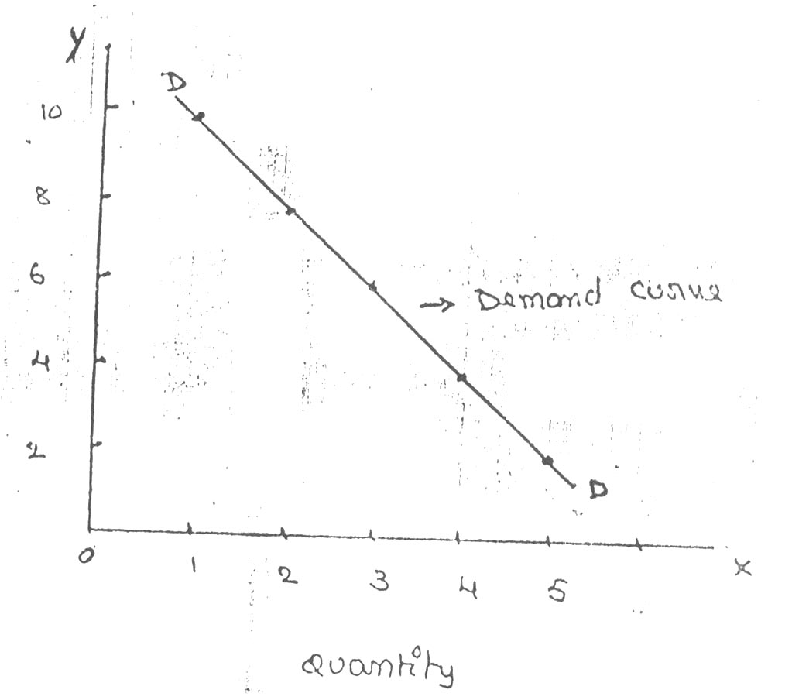

Price

The demand curve DD shows the inverse relation between price and quantity demand of apple. It is downward sloping.

***Assumptions:***

Law is demand is based on certain assumptions:

1. This is no change in consumers taste and preferences.
2. Income should remain constant.
3. Prices of other goods should not change.
4. There should be no substitute for the commodity
5. The commodity should not confer at any distinction
6. The demand for the commodity should be continuous
7. People should not expect any change in the price of the commodity

***Exceptional demand curve:***

Some times the demand curve slopes upwards from left to right. In this case the demand curve has a positive slope.

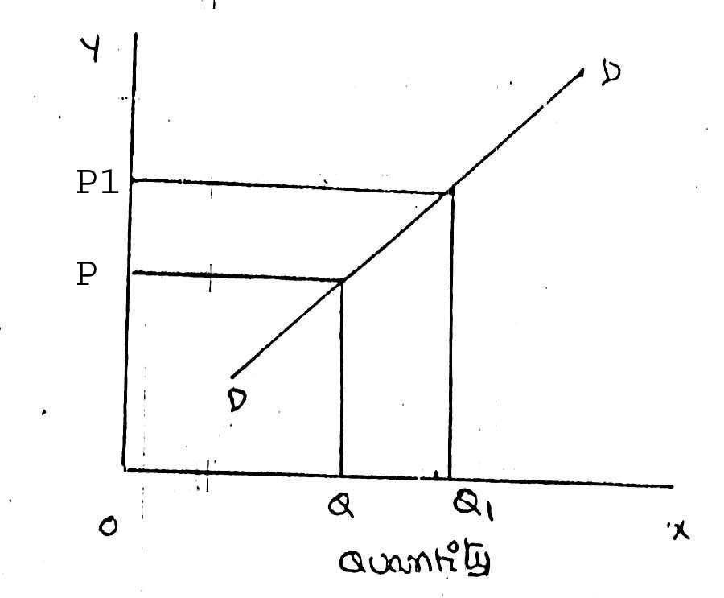

Price

When price increases from OP to Op1 quantity demanded also increases from to OQ1 and vice versa. The reasons for exceptional demand curve are as follows.

***1. Giffen paradox:***

The Giffen good or inferior good is an exception to the law of demand. When the price of an inferior good falls, the poor will buy less and vice versa. For example, when the price of maize falls, the poor are willing to spend more on superior goods than on maize if the price of maize increases, he has to increase the quantity of money spent on it. Otherwise he will have to face starvation. Thus a fall in price is followed by reduction in quantity demanded and vice versa. “Giffen” first explained this and therefore it is called as Giffen’s paradox.

***2. Veblen or Demonstration effect :***‘Veblan’ has explained that the rich people buy certain good because it gives social distinction or prestige. For example diamonds are bought by the richer class for the prestige it possess. It the price of diamonds falls poor also will buy is hence they will not give prestige. Therefore, rich people may stop buying this commodity.

***3. Ignorance:*** Sometimes, the quality of the commodity is Judge by its price. Consumers think that the product is superior if the price is high. As such they buy more at a higher price.

***4. Speculative effect:***In the speculative market, a rise in pries is frequently followed by larger purchases and a fall in prices by small purchases. When share prices rise, people expect further rise and rush to buy when prices fall, they wait for further fall and stop buying.

***5. Fear of shortage:*** During the times of emergency of war People may expect shortage of a commodity. At that time, they may buy more at a higher price to keep stocks for the future.

***6.Necessaries:*** In the case of necessaries like rice, vegetables etc. people buy more even at a higher price.

**ELASTICITY OF DEMAND**

Elasticity of demand explains the relationship between a change in price and consequent change in amount demanded. “Marshall” introduced the concept of elasticity of demand. Elasticity of demand shows the extent of change in quantity demanded to a change in price.

In the words of “Marshall”, “The elasticity of demand in a market is great or small according as the amount demanded increases much or little for a given fall in the price and diminishes much or little for a given rise in Price”

**Elastic demand:** A small change in price may lead to a great change in quantity demanded. In this case, demand is elastic.

**In-elastic demand:** If a big change in price is followed by a small change in demanded then the demand in “inelastic”.

**Types of Elasticity of Demand:** There are three types of elasticity of demand:

1. Price elasticity of demand
2. Income elasticity of demand
3. Cross elasticity of demand

**1. Price elasticity of demand:**

Marshall was the first economist to define price elasticity of demand. Price elasticity of demand measures changes in quantity demand to a change in Price. It is the ratio of percentage change in quantity demanded to a percentage change in price.

Proportionate change in the quantity demand of commodity

**Price elasticity** = ------------------------------------------------------------------

Proportionate change in the price of commodity

There are five cases of price elasticity of demand

**A. Perfectly elastic demand:**

When small change in price leads to an infinitely large change is quantity demand, it is called perfectly or infinitely elastic demand. In this case E=∞

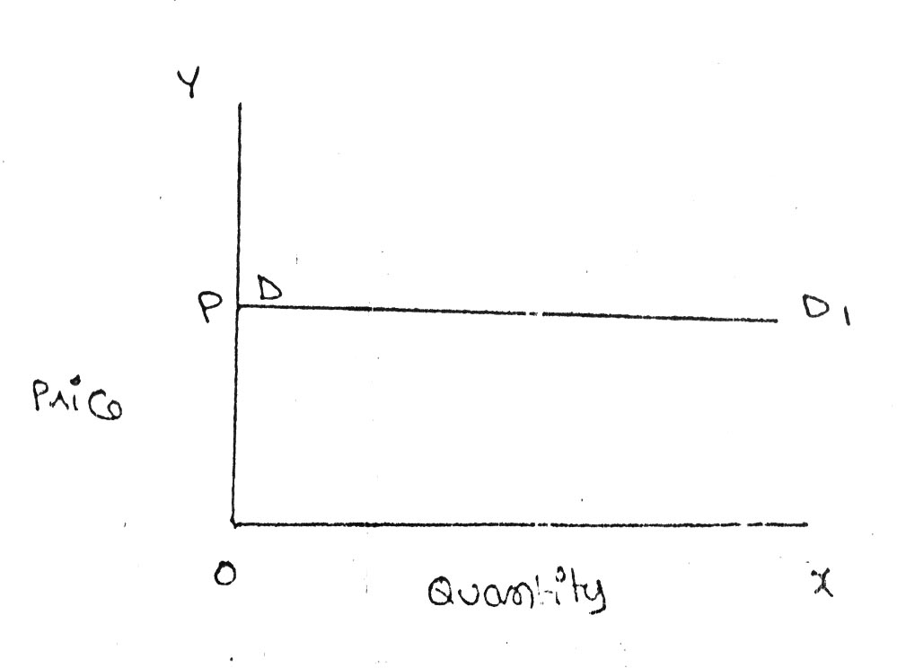

The demand curve DD1 is horizontal straight line. It shows the at “OP” price any amount is demand and if price increases, the consumer will not purchase the commodity.

**B. Perfectly Inelastic Demand**

In this case, even a large change in price fails to bring about a change in quantity demanded.

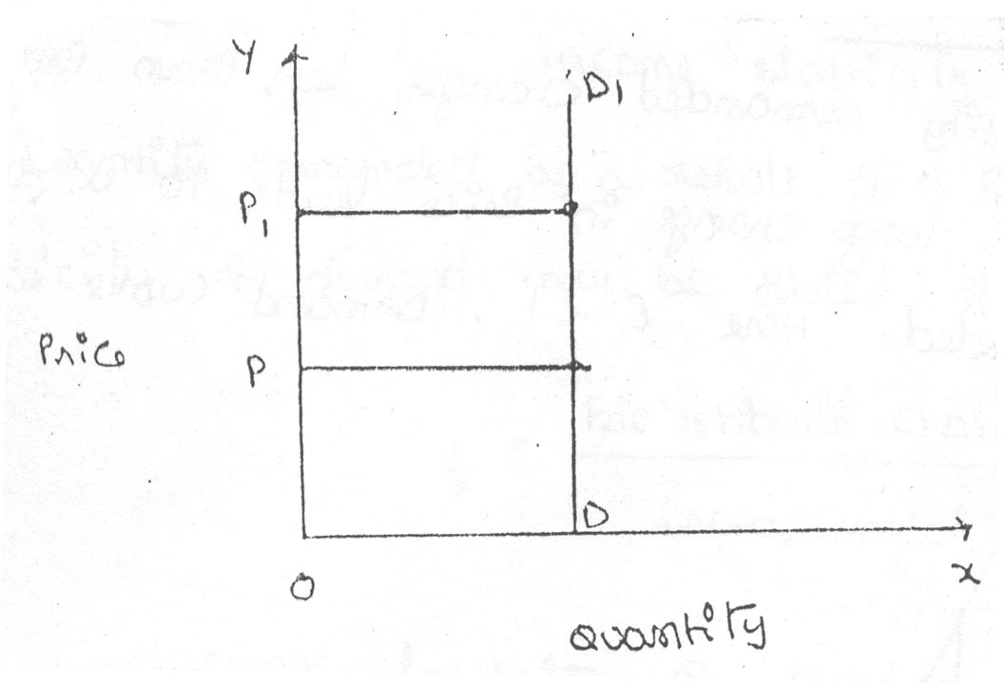

When price increases from ‘OP’ to ‘OP’, the quantity demanded remains the same. In other words the response of demand to a change in Price is nil. In this case ‘E’=0.

**C. Relatively elastic demand:**

Demand changes more than proportionately to a change in price. i.e. a small change in price loads to a very big change in the quantity demanded. In this case

E > 1. This demand curve will be flatter.

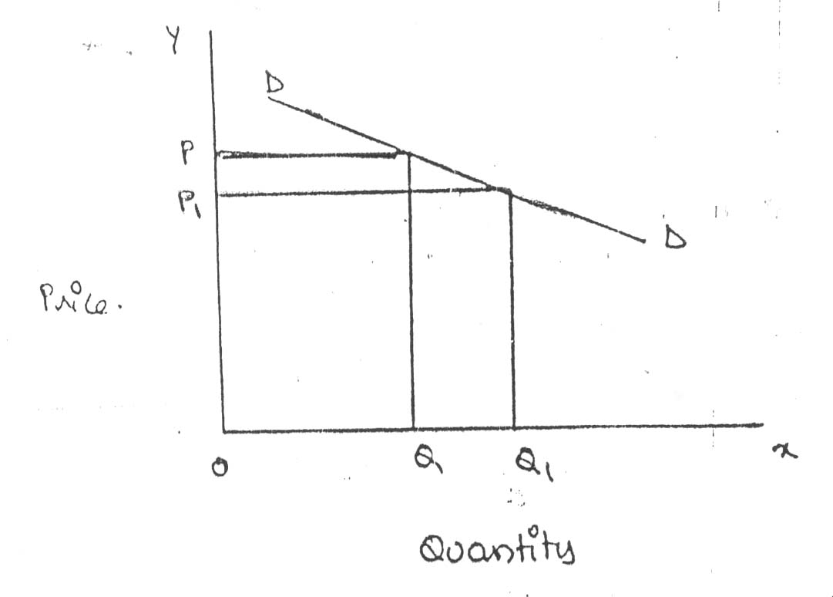

When price falls from ‘OP’ to ‘OP’, amount demanded in crease from “OQ’ to “OQ1’ which is larger than the change in price.

**D. Relatively in-elastic demand.**

Quantity demanded changes less than proportional to a change in price. A large change in price leads to small change in amount demanded. Here E < 1. Demanded carve will be steeper.

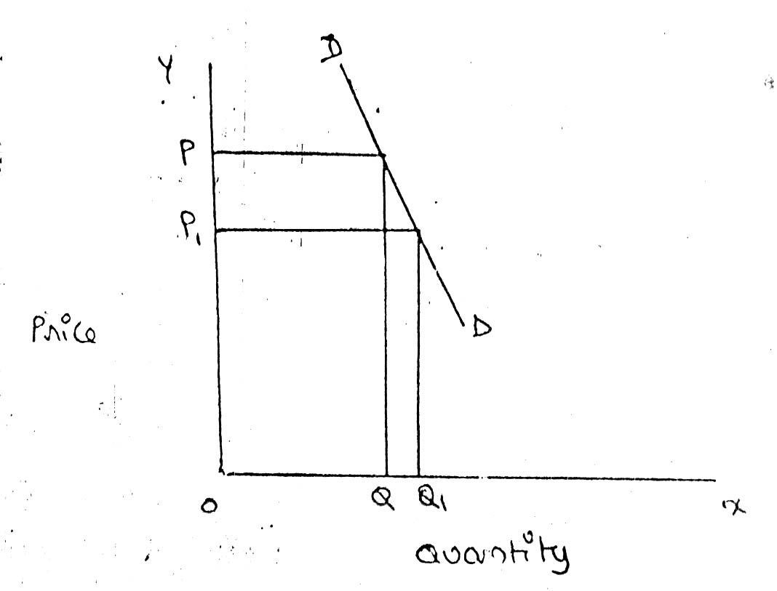

When price falls from “OP’ to ‘OP1 amount demanded increases from OQ to OQ1, which is smaller than the change in price.

**E. Unit elasticity of demand:**

The change in demand is exactly equal to the change in price. When both are equal E=1 and elasticity if said to be unitary.

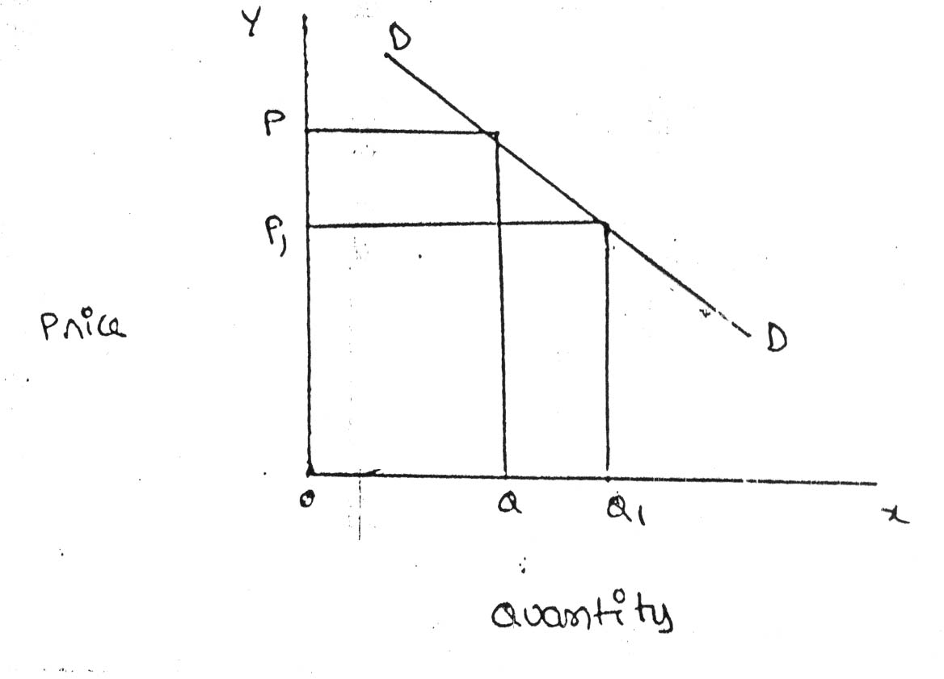

When price falls from ‘OP’ to ‘OP1’ quantity demanded increases from ‘OP’ to ‘OP1’, quantity demanded increases from ‘OQ’ to ‘OQ1’. Thus a change in price has resulted in an equal change in quantity demanded so price elasticity of demand is equal to unity.

**2. Income elasticity of demand:** Income elasticity of demand shows the change in quantity demanded as a result of a change in income. Income elasticity of demand may be slated in the form of a formula.

Proportionate change in the quantity demand of commodity

**Income Elasticity** = ------------------------------------------------------------------

Proportionate change in the income of the people

Income elasticity of demand can be classified in to **five** types.

**A. Zero income elasticity:** Quantity demanded remains the same, even though money income increases. Symbolically, it can be expressed as Ey=0. It can be depicted in the following way:

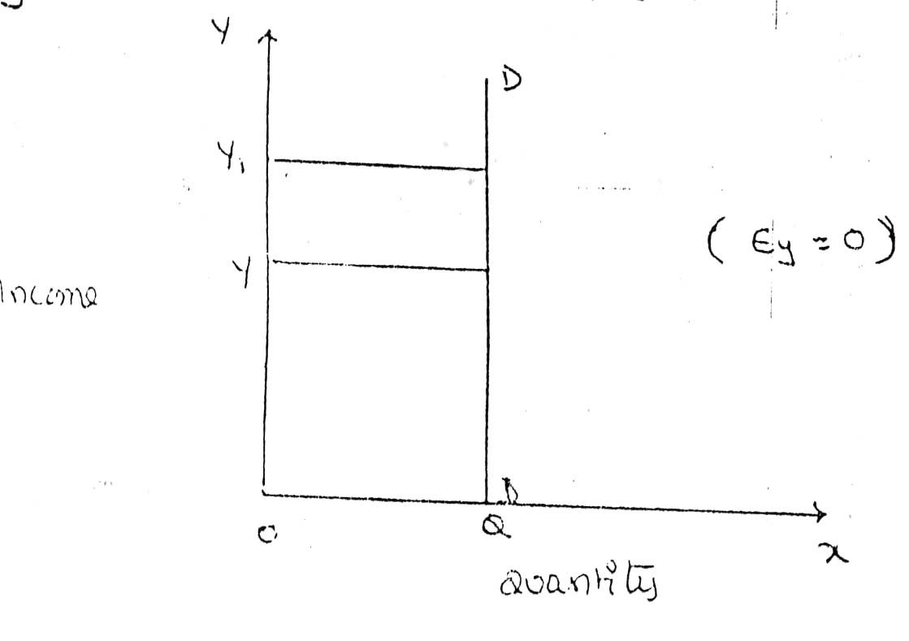

As income increases from OY to OY1, quantity demanded never changes.

**B. Negative Income elasticity:** When income increases, quantity demanded falls. In this case, income elasticity of demand is negative. i.e., Ey < 0.

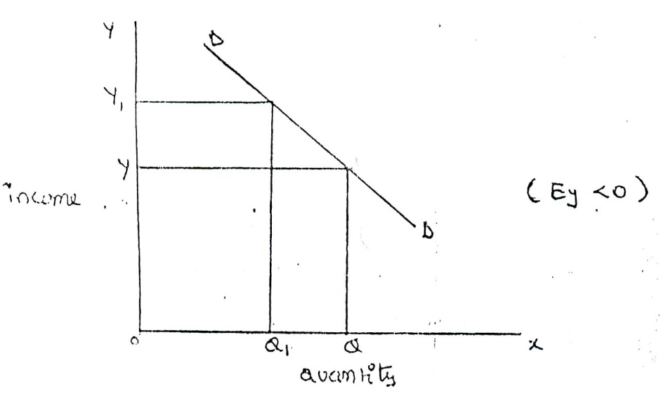

When income increases from OY to OY1, demand falls from OQ to OQ1.

**C. Unit income elasticity:** When an increase in income brings about a proportionate increase in quantity demanded, and then income elasticity of demand is equal to one. Ey = 1

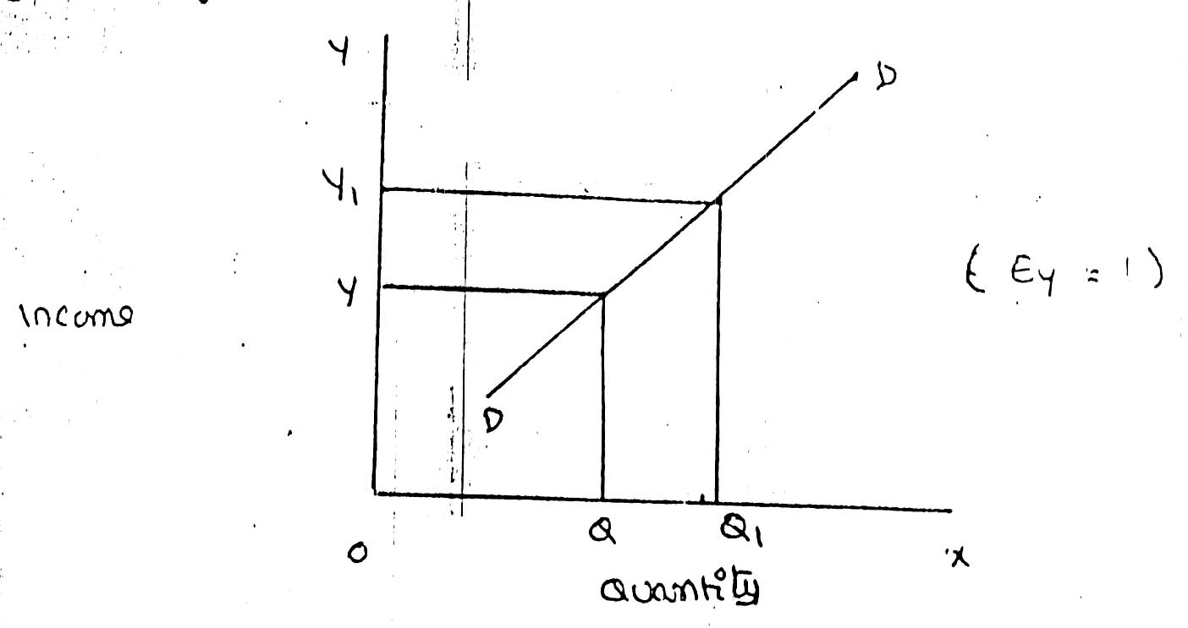

When income increases from OY to OY1, Quantity demanded also increases from OQ to OQ1.

**D. Income elasticity greater than unity:** In this case, an increase in come brings about a more than proportionate increase in quantity demanded. Symbolically it can be written as Ey > 1.

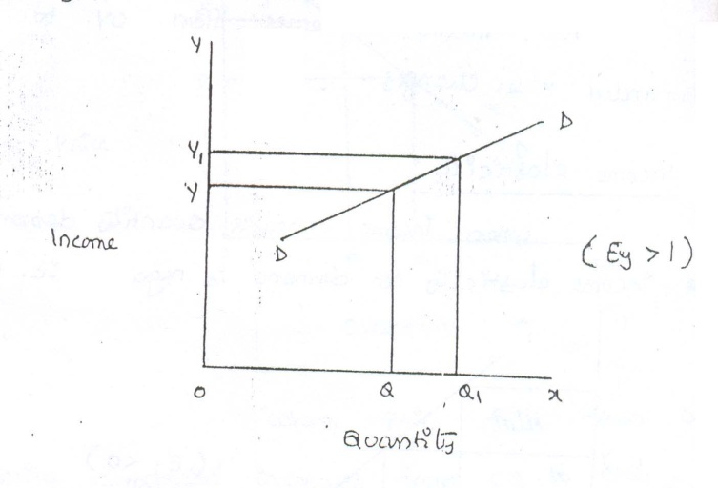

It shows high-income elasticity of demand. When income increases from OY to OY1, Quantity demanded increases from OQ to OQ1.

**E. Income elasticity leas than unity:**

When income increases quantity demanded also increases but less than proportionately. In this case E < 1.

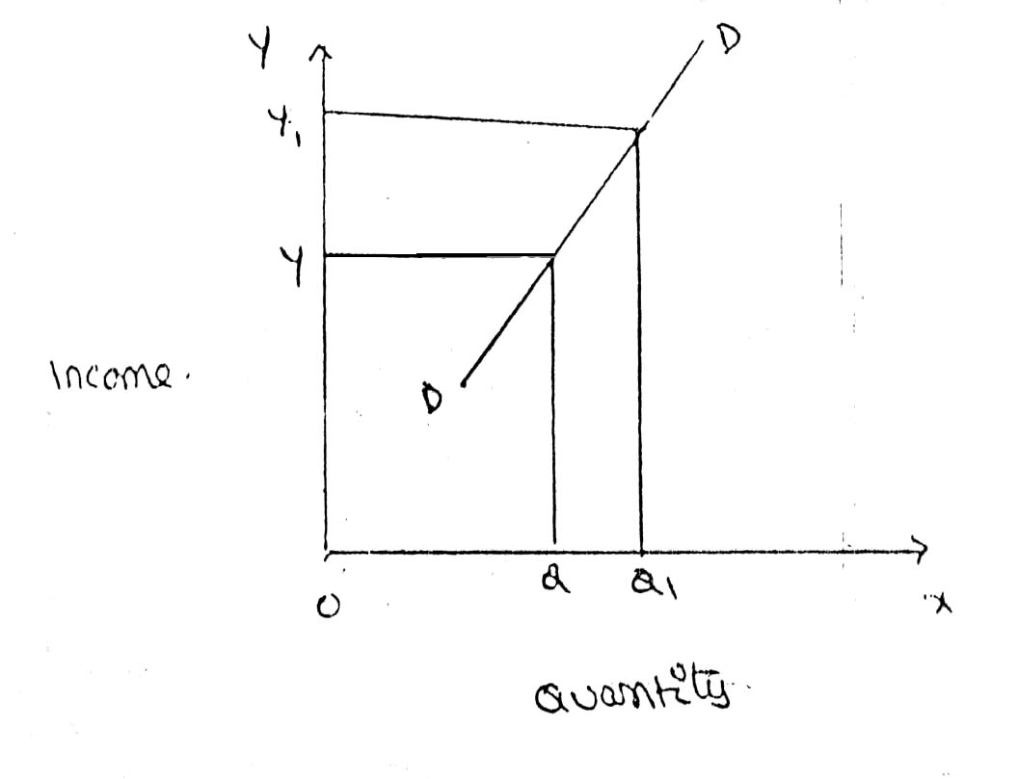

An increase in income from OY to OY, brings what an increase in quantity demanded from OQ to OQ1, But the increase in quantity demanded is smaller than the increase in income. Hence, income elasticity of demand is less than one.

**3. Cross elasticity of Demand:**

A change in the price of one commodity leads to a change in the quantity demanded of another commodity. This is called a cross elasticity of demand. The formula for cross elasticity of demand is:

Proportionate change in the quantity demand of commodity “**X”**

**Cross elasticity** = -----------------------------------------------------------------------

Proportionate change in the price of commodity “**Y”**

**A..** **In case of substitutes**, cross elasticity of demand is positive. Eg: Coffee and Tea

When the price of coffee increases, Quantity demanded of tea increases. Both are substitutes.

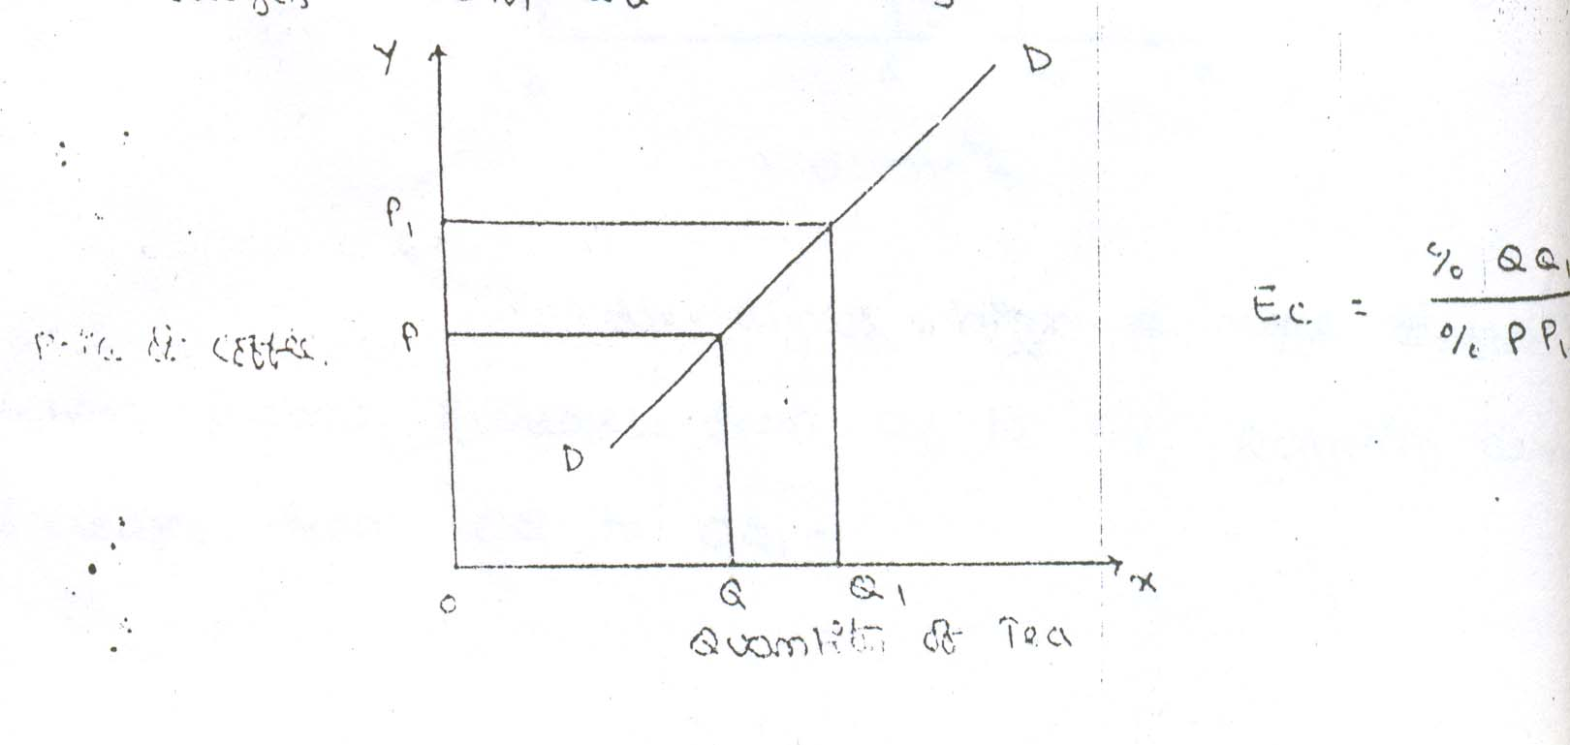

Price of Coffee

**B.** **Incase of compliments**, cross elasticity is negative. If increase in the price of one commodity leads to a decrease in the quantity demanded of another and vice versa.

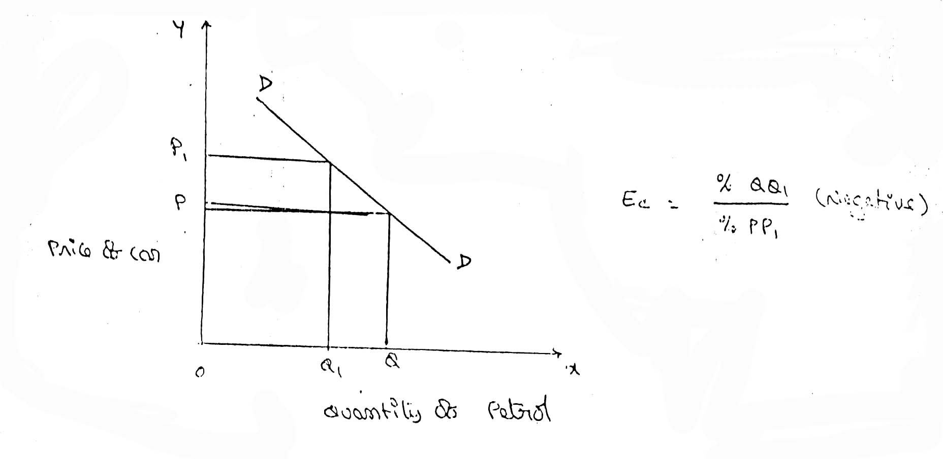

When price of car goes up from OP to OP!, the quantity demanded of petrol decreases from OQ to OQ!. The cross-demanded curve has negative slope.

**c.** **In case of unrelated commodities**, cross elasticity of demanded is zero. A change in the price of one commodity will not affect the quantity demanded of another.

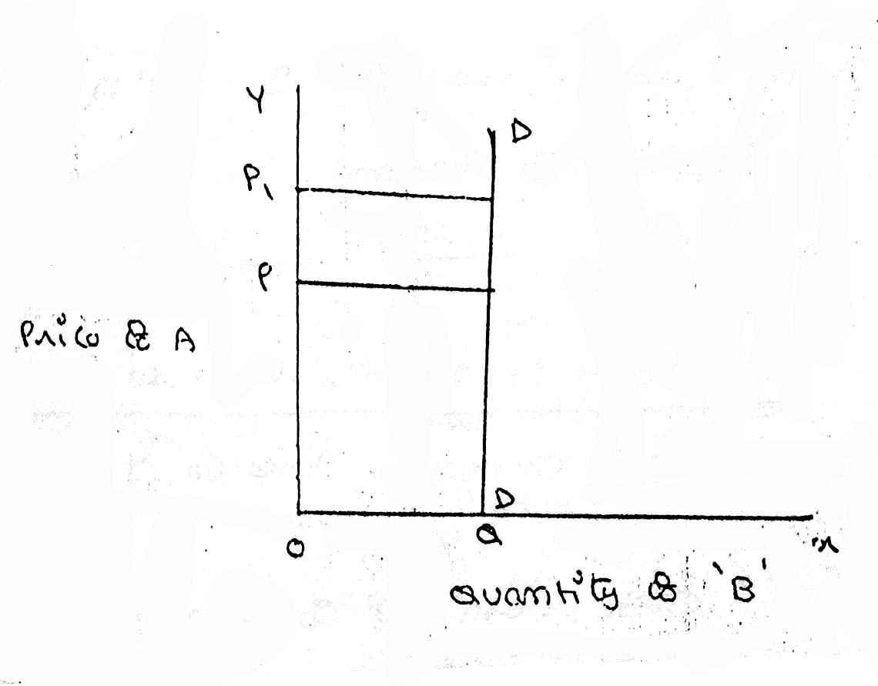

Quantity demanded of commodity “b” remains unchanged due to a change in the price of ‘A’, as both are unrelated goods.

**MEASUREMENT OF ELASTICITY OF DEMAND:**

**1. Percentage Method:**

In this method the elasticity of demand is measured by comparing the percentage change in price with the percentage change in demand.

1. When the percentage change in demand is greater than the percentage change in price, then it is said to be elastic demand. Then the elasticity of demand will be greater than one.

|  |  |
| --- | --- |
| Price | Demand |
| 10 | 1000 |
| 8 | 1500 |

In them above table the percentage change in price is 20 and the percentage change in demand is 50. Here the percentage change in demand is greater than the percentage change in price. So the elasticity of demand is greater than one.

1. When the percentage change in demand equal to the percentage change in price, then it is said to be unitary elastic demand. Then the elasticity of demand will equal to one.

|  |  |
| --- | --- |
| Price | Demand |
| 10 | 1000 |
| 8 | 1200 |

In them above table the percentage change in price is 20 and the percentage change in demand is 20. Here the percentage change in demand is equal to the percentage change in price. Therefore demand is said to be unitary elastic demand. So the elasticity of demand is equal to one.

1. When the percentage change in demand less than the percentage change in price, then it is said to be inelastic demand. Then the elasticity of demand will be less than one.

|  |  |
| --- | --- |
| Price | Demand |
| 10 | 1000 |
| 8 | 1100 |

In them above table the percentage change in demand is 10 and the percentage change in price is 20. Here the percentage change in demand is less than the percentage change in price. So the elasticity of demand is less than one.

**2. Total Expenditure or Total outlay Method:**

In this method the elasticity of demand is measured by comparing the total expenditure made by the consumer at different prices. When the decline in the price leads to increase in the total expenditure on commodities, the it is elastic demand. Suppose there is no change in the total expenditure even though the price is changed and the it is known as unitary elastic demand. If the total expenditure is decreased due to decline in the price level., then it is known as inelastic demand.

This total outlay method can be explained with the help of the following demand schedule:

|  |  |  |  |
| --- | --- | --- | --- |
| **Price Per Unit** | **Quantity demand** | **Total outlay** | **Type of elasticity** |
| 5 | 20 | 100 | Ed>1 |
| 4 | 30 | 120 |
| 5 | 20 | 100 | Ed=1 |
| 4 | 25 | 100 |
| 5 | 20 | 100 | Ed<1 |
| 4 | 22 | 88 |

In the above table previously when the price is reduced from Rs 5n to Rs 4 the total expenditure was increased from Rs 100 to Rs 120. Therefore, it is said to be elastic demand.

Later, even though the price has declined from Rs.5 to Rs.4, there is no change in total expenditure and it remains as Rs 100. Therefore, it is considered as unitary elastic demand.

Finally, the total expenditure was declined from Rs.100to Rs.88 due to decline in price level from Rs. 5 to Rs 4 and therefore it is considered as inelastic demand.

The Total Outlay method can be explained with the help of diagram:

Y

D E>1

Price

E=1

E<1

D1

**X**

Total Expenditure

In the above diagram on X-axis the total expenditure and on Y-axis the price are determined.AD is the total Outlay Curve. AB portion shows the nature of elastic demand. BC shows, the unitary elastic demand and CD shows the inelastic demand. In the diagram due to decline in the price level, at first stage the total expenditure has increased, later constant and finally it was declined.

3. **Point elasticity Method:**

In this the elasticity of demand is measured at a particular point on the demand curve. The point elasticity of demand is equal to the distance between the point and X-axis i.e, lower segment divided by the distance between the point and Y-axis i.e, upper segment, if the result is more than one, then it is elastic one, if the result is equal to one, then it is unitary elastic demand and if the result is less than one, then it can be considered inelastic demand.

Y

t

Price L E<1

K E=1

M E>1

T

**X**

Total Expenditure

In the diagram on X-axis the demand and on Y-axis the price are determined. K is the point on the demand curve. At that point we can know the elasticity of demand with the help of following formula.

Point elasticity=KT/Kt

After application of the above formula if the result is equal to one, then the elasticity of demand is equal to one. At point J, the elasticity of demand is greater than one and at point L there is inelastic demand.

**ARC Elasticity Method:**

Instead of measuring elasticity at a point , we measure it over larger segment of the demand curve, we get ARC elasticity measure. The arc elasticity is the measure of average elasticity. i.e. it is the elasticity at the midpoint of the chord that connects the initial and new point on the demand curve. In the figure the end points of the curve (P1, Q1) (P2, Q2).

In figure above we can evaluate arc elasticity among points A and B on the demand curve; we will have to acquire the average prices of OP1 and OP2 and average of the two amounts demanded (i.e., original and new).

**Arc method:**

Segment of a demand curve among two points is termed as an Arc.

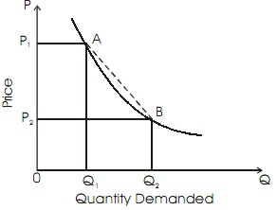

Figure: Arc Elasticity

Arc elasticity is evaluated from the formula given below:

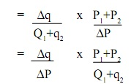

Here,

ΔQ= modify in quantity demanded  
ΔP = modify in price of the commodity  
P1= unique price  
P2 = fresh price  
Q1 = unique quantity  
Q2 = fresh quantity

Arc elasticity formula must be employed whenever the change in price is somewhat big.

**DEMAND FORECASTING**

**Introduction:**

The information about the future is essential for both new firms and those planning to expand the scale of their production. Demand forecasting refers to an estimate of future demand for the product.

It is an ‘objective assessment of the future course of demand”. Demand forecasting has an important influence on production planning. It is essential for a firm to produce the required quantities at the right time.

It is essential to distinguish between forecasts of demand and forecasts of sales. Sales forecast is important for estimating revenue cash requirements and expenses. Demand forecasts relate to production, inventory control, timing, reliability of forecast etc. However, there is not much difference between these two terms.

**Types of demand Forecasting:**

Based on the time span and planning requirements of business firms, demand forecasting can be classified in to 1. Short-term demand forecasting and

2. Long – term demand forecasting.

***1. Short-term demand forecasting:***

Short-term demand forecasting is limited to short periods, usually for one year. It relates to policies regarding sales, purchase, price and finances. It refers to existing production capacity of the firm..

***2. Long – term forecasting:***

In long-term forecasting, the businessmen should now about the long-term demand for the product. Planning of a new plant or expansion of an existing unit depends on long-term demand.

**Methods of forecasting:**

Several methods are employed for forecasting demand. All these methods can be grouped under survey method and statistical method. Survey methods and statistical methods are further subdivided in to different categories.

**Methods of Forecasting**

***Survey Method Statistical Methods***

***A. Opinion survey method a. Time series analysis or trend projection methods:***

***B. Expert opinion method: b. Barometric Technique:***

***C. Delphi Method: c. Regression and correlation method:***

***D. Consumers interview method:***

***1. Survey Method:***

Under this method, information about the desires of the consumer and opinion of exports are collected by interviewing them. Survey method can be divided into four type’s viz., Option survey method; expert opinion; Delphi method and consumers interview methods.

***a. Opinion survey method:***

This method is also known as **sales-force composite method** (or) **collective opinion method**. Under this method, the company asks its salesman to submit estimate of future sales in their respective territories. Since the forecasts of the salesmen are biased due to their optimistic or pessimistic attitude ignorance about economic developments etc. these estimates are consolidated, reviewed and adjusted by the top executives. In case of wide differences, an average is struck to make the forecasts realistic.

This method is more useful and appropriate because the salesmen are more knowledge. They can be important source of information. They are cooperative. The implementation within unbiased or their basic can be corrected.

***B. Expert opinion method:***

Apart from salesmen and consumers, distributors or outside experts may also e used for forecasting. In the United States of America, the automobile companies get sales estimates directly from their dealers. Firms in advanced countries make use of outside experts for estimating future demand. Various public and private agencies all periodic forecasts of short or long term business conditions.

***C. Delphi Method:***

A variant of the survey method is Delphi method. It is a sophisticated method to arrive at a consensus. Under this method, a panel is selected to give suggestions to solve the problems in hand. Both internal and external experts can be the members of the panel. Panel members one kept apart from each other and express their views in an anonymous manner. There is also a coordinator who acts as an intermediary among the panelists. He prepares the questionnaire and sends it to the panelist. At the end of each round, he prepares a summary report. On the basis of the summary report the panel members have to give suggestions. This method has been used in the area of technological forecasting. It has proved more popular in forecasting. It has provided more popular in forecasting non-economic rather than economic variables.

***D. Consumers interview method:***

In this method the consumers are contacted personally to know about their plans and preference regarding the consumption of the product. A list of all potential buyers would be drawn and each buyer will be approached and asked how much he plans to buy the listed product in future. He would be asked the proportion in which he intends to buy. This method seems to be the most ideal method for forecasting demand.

***2. Statistical Methods:***

Statistical method is used for long run forecasting. In this method, statistical and mathematical techniques are used to forecast demand. This method relies on post data.

***a. Time series analysis or trend projection methods:***

A well-established firm would have accumulated data. These data are analyzed to determine the nature of existing trend. Then, this trend is projected in to the future and the results are used as the basis for forecast. This is called as time series analysis. This data can be presented either in a tabular form or a graph. In the time series post data of sales are used to forecast future.

***b. Barometric Technique:***

Simple trend projections are not capable of forecasting turning paints. Under Barometric method, present events are used to predict the directions of change in future. This is done with the help of economics and statistical indicators. Those are (1) Construction Contracts awarded for building materials (2) Personal income (3) Agricultural Income. (4) Employment (5) Gross national income (6) Industrial Production (7) Bank Deposits etc.

***c. Regression and correlation method:***

Regression and correlation are used for forecasting demand. Based on past data the future data trend is forecasted. If the functional relationship is analyzed with the independent variable it is simple correction. When there are several independent variables it is multiple correlation. In correlation we analyze the nature of relation between the variables while in regression; the extent of relation between the variables is analyzed. The results are expressed in mathematical form. Therefore, it is called as econometric model building. The main advantage of this method is that it provides the values of the independent variables from within the model itself.